

**Overview of IoT systems architecture, key components, and communication protocols**

**IoT Lab**

**Student Name: Mohamad Osman**

**#Task 2**

**Submission Date: 14/06/2020**

**#Task 2:**

**DC Motor circuit**

* **Connect directly to power source**
* **Connect using transistor (2N2222 or TIP120)**

**LED and DC motor circuit using push buttons**

* **One push button turns on both of Motor and LED**

As shown in Figure 1, I used **“Tinkercad”** website to simulate and build the circuit  
:

**Requirements:**

* NPN Transistor 2N2222
* Diode
* Push button
* LED
* Dc Motor
* Resistors [Transistor (1kꭥ), LED (220ꭥ), pushbutton(10kꭥ)]

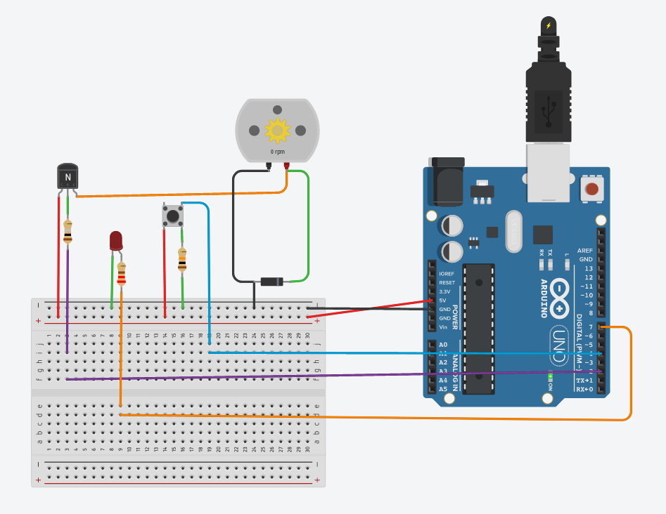

***Figure 1: the circuit diagram of Dc Motor&LED controlled by push button***

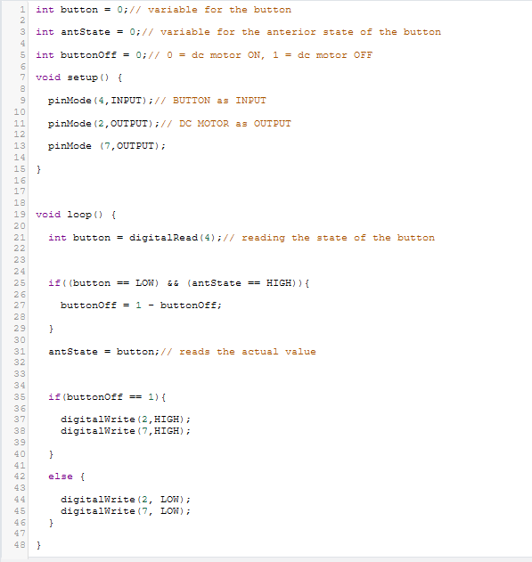**The code:**

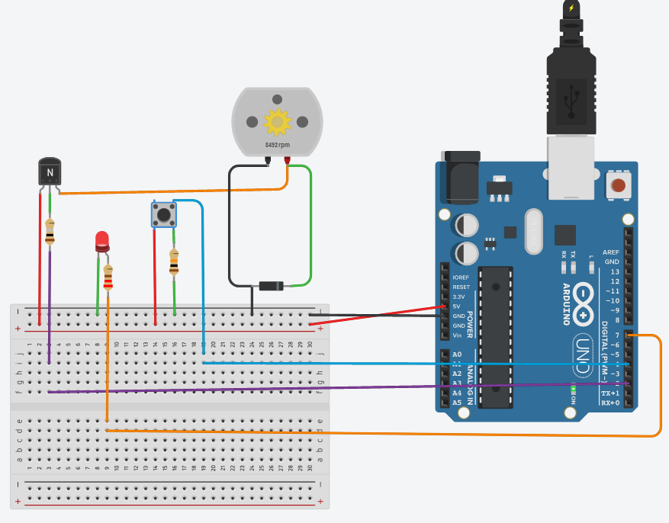

***Figure 2 O/P of the circuit after push button is pressed.***

What are the colors of the following resistors (4 Colors)?

Bands Reading: From Left to Right

**220Ω:**

Red (2), Red (2), Brown (x101).

**470Ω:**

Yellow (4), Violet (7), Brown (x101), Gold (5% tolerance).

**1KΩ:**

Brown (1), Black (0), Red(x102), Gold (5% tolerance).

**1.2K Ω:**

Brown (1), Red (2), Red(x102), Gold (5% tolerance).

**4.7KΩ:**

Yellow (4), Violet (7), Red(x102), Gold (5% tolerance).

**100KΩ:**

Brown (1), Black (0), Yellow (x103), Gold (5% tolerance).